Outputs for Q2)C)

Matrix Addition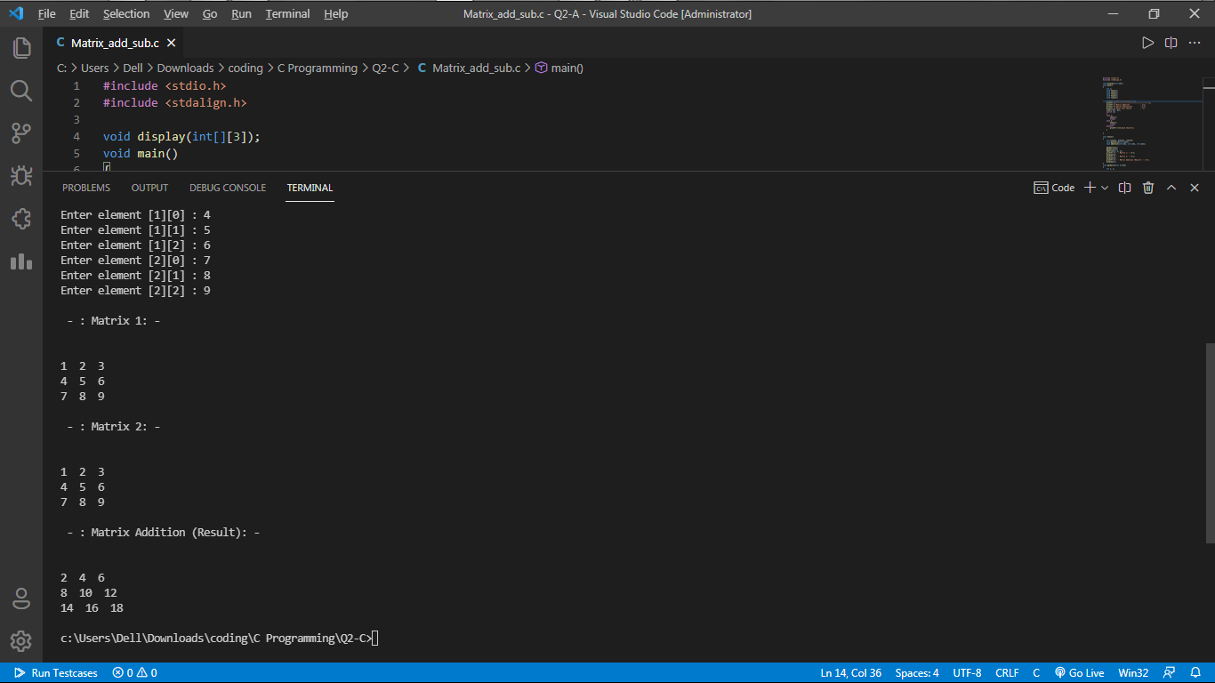

Matrix Subtraction

